PROJECT REPORT ON

“LIBRARY MANAGEMENT SYSTEM”

Submitted in partial fulfilment of 2nd Semester

MASTER OF COMPUTER APPLICATION

Of

Visvesvaraya Technological University



MD MIRAJ ANSARI (1AY18MCA14)

Under the Guidance of

Dr. SURESH BABU



Acharya Institute of Technology

Acharya Dr.SarvepalliRadhakrishna Road,

Soldevanahalli,Hesaraghatta Main Road,

Bengaluru -56

[www.acharya.ac.in](http://www.acharya.ac.in)

2018-2019

**ACHARYA INSTITUTE OF TECHNOLOGY**

**Department of MCA**

**(**Affiliated to Visvesvaraya Technological University,Bengaum**)**

Acharya Dr.SarvepalliRadhakrishnan Road,

Acharya P.O,Bengaluru -560107



CERTIFICATE

This is to certify that java project entitled

“LIBRARY MANAGEMENT SYSTEM”

Submitted in the partial fulfillment of requirement of the 2nd  semester

Of

**Master of Computer Application**

is a result of the bonafied work carried out by

MD MIRAJ ANSARI (1AY18MCA14)

During the academic year 2018-2019

Project Guide Head of the Department

Dr. Suresh Babu Dr.Ramesh Hegde

Professor Professor,HOD

Department of MCA Department of MCA

Acharya Institute of Technology Acharya institute of Technology

# ACKNOWLEDGEMENT

We take this occasion to thank God, almighty for blessing us with his grace and taking our endeavor to a successful culmination. We extend our sincere and heartfelt thanks to our esteemed guide, **Prof. Dr.G.N.K.Suresh Babu**, for providing us with the right guidance and advice at the crucial junctures and for showing me the right way. We extend our sincere thanks to our respected **Head of the Department Dr. Ramesh Hegde**, for allowing us to use the facilities available. We would like to thank the other faculty members also, on this occasion. Last but not least, we would like to thank our friends and family for the support and encouragement they have given us during the course of our work.

## TABLE OF CONTENTS

|  |  |  |
| --- | --- | --- |
| **SL. NO** | **INDEX** | **PG .NO** |
| 1 | ABSTRACT |  |
| 2 | INTRODUCTION |  |
| 3 | PROPOSED SYSTEM |  |
|  | Module description |  |
| 4 | REQUIREMENT SPECIFICATION |  |
|  | 1. Non functional requirement |  |
|  | 1. Functional requirement |  |
| 5 | DATA FLOW DIAGRAM |  |
|  | Level -0 |  |
|  | Level -1 |  |
|  | Level-2 |  |
| 6 | USE CASE DIAGRAM |  |
| 7 | SCREENSHOTS |  |
| 8 | CONCLUSION & FUTURE SCOPE |  |

**ABSTRACT**

Library management system is a project which aims in developing a computerized system to maintain all the daily work of library .This project has many features which are generally not availiable in normal library management systems like facility of user login and a facility of teachers login .

Library Management System is an application which refers to library systems which are generally small or medium in size. It is used by librarian to manage the library using a computerized system where he/she can record various transactions like issue of books, return of books, addition of new books, addition of new students etc

Overall this project of ours is being developed to help the students as well as staff of library to maintain the library in the best way possible and also reduce the human efforts.

**INTRODUCTION**

The main objective of the Library Management system is organizing and managing the library tasks. Library is place where all kind of books are available. This is a web base application and only a registered user can access the application. Library Management system is developed to automate the task of entering the records of new book and retrieving the details of book available in the library. This system contains list of all the books. Using this system user can issue book to the library member, maintain their records, and can checks how many book are issued and how many books are available in the library.  Using the library management system, user can also maintain the late fine of library member who return the issued book after the due date.

**Proposed System:**

In the proposed system, we assume that each member will be having a identity card which can be used for the library book issue, fine payment etc. whenever library member wish to take a book, the book issued by the library authority will be check both the book details as well as the student details and store it in library database. In case of retrieval of book much of human intervention can be eliminated.

Module Description:

         1. User Module:

In this module student can check availability of the book…

The following are the sub module in the user module.

Book return: Here student will return the books  to the library…

2. Administrator Module:

This is the main module in the proposed project. The administrator can read and write information about any member. The administrator can also update, create and delete the record of membership as per requirement and implementation plans.

The following are the sub module in the administrator module.

Register student: Allow the administrator to register new student and update the student records.

Book details: Allow administrator to entered book details.

Book issue: Here administrator issues the books to the student from library.

**REQUIREMENT SPECIFICATION**

NON FUNCTIONAL REQUIREMENTS

Product Requirements EFFICIENCY REQUIREMENT When a library management system will be implemented librarian and user will easily acess library as searching and book transaction will be very faster .RELIABILITY REQUIREMENT The system should accurately performs member registration ,member validation ,report generation, book transaction and search USABILITY REQUIREMENT The system is designed for a user friendly environment so that student and staff of library can perform the various tasks easily and in an effective way. ORGANIZATIONAL REQUIREMENT IMPLEMENTATION REQUIREMNTS In implementing whole system it uses java in front end with sqlite as server side scripting language which will be used for database connectivity and the backend ie the database part is developed using sqlite DELIVERY REQUIREMENTS The whole system is expected to be delivered in six months of time with a weekly evaluation by the project guide

FUNCTIONAL REQUIREMENTS

NORMAL USER1.1 USER LOGIN Description of featureThis feature used by the user to login into system. They are required to enter user id and password before they are allowed to enter the system .The user id and password will be verified and if invalid id is there user is allowed to not enter the system. Functional requirements-user id is provided when they register-The system must only allow user with valid id and password to enter the system-The system performs authorization process which decides what user level can acess to.-The user must be able to logout after they finished using system.1.2 REGISTER NEW USER Description of feature. This feature can be performed by all users to register new user to create account .Functional requirements-System must be able to verify information-System must be able to delete information if information is wrong.

REGISTER NEW BOOK Description of feature This feature allows to add new books to the library Functional requirements-System must be able to verify information-System must be able to enter number of copies into table.- System must be able to not allow two books having same book id.

1.5 SEARCH BOOK DESCRIPTION OF FEATURE This feature is found in book maintenance part . we can search book based on book id , book name , publication or by author name.

Functional requirements-

System must be able to search the database based on select search type-System must be able to filter book based on keyword enterd-System must be able to show the filtered book in table view1.5 ISSUE BOOKS AND RETURN BOOKS DESCRIPTION OF FEATURE This feature allows to issue and return books and also view reports of book issued.Functional requirements-System must be able to enter issue information in database.-System must be able to update number of books.-System must be able to search if book is available or not before issuing books-System should be able to enter issue and return date information1.6 EVENT ADDITIONDESCRIPTION OF FEATURE This feature allows teacher and student to add information about various workshops beingconducted in college and colleges nearby

**DATA FLOW DIAGRAM**

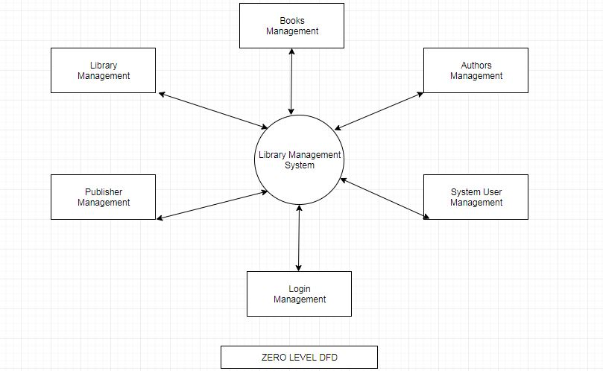

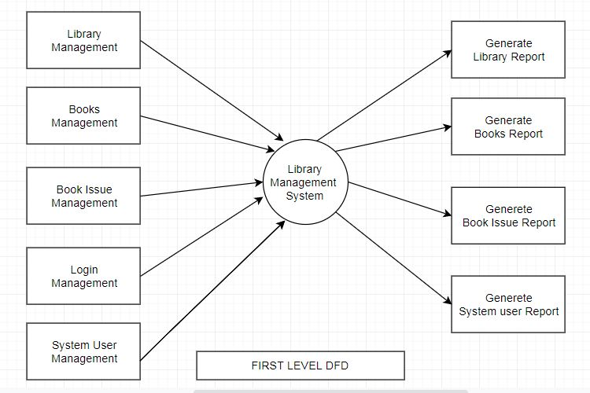

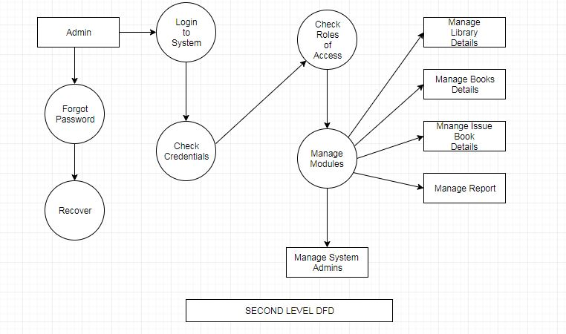

**USE CASE DIAGRAM**

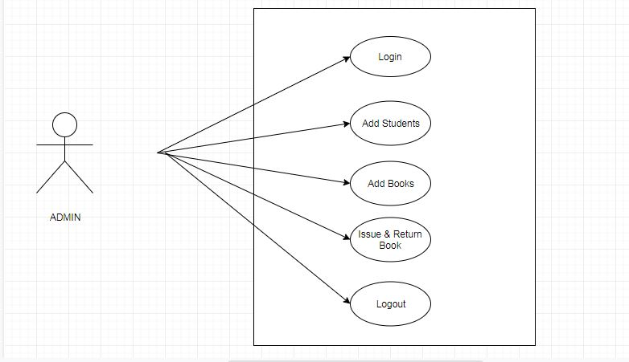

**SCREENSHOT**

**LOGIN**

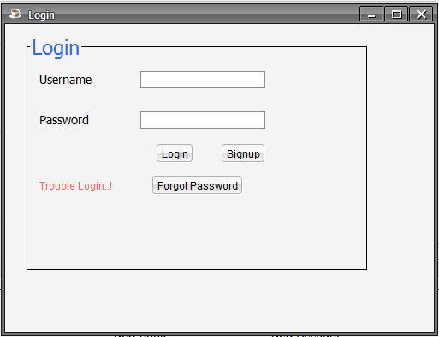

**SIGNUP**

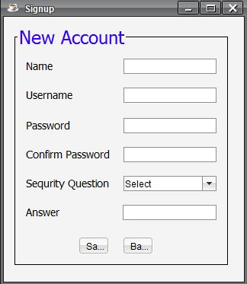

**FORGOT PASSWORD**

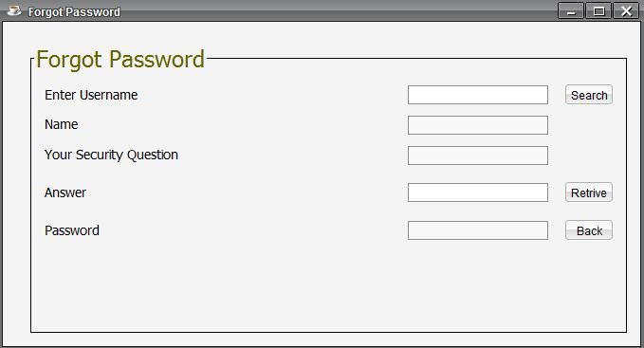

**ADMIN DASHBOARD**

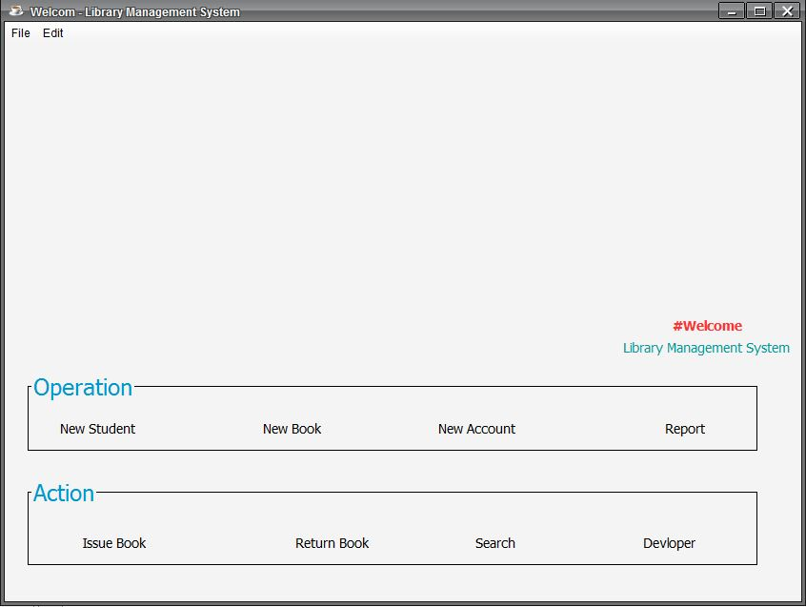

**ADD STUDENT**

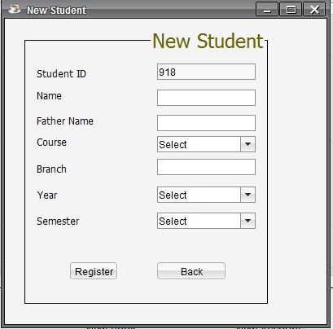

**ADD BOOKS**

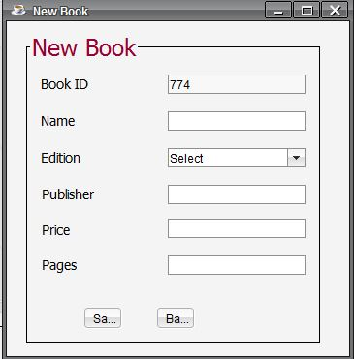

**ADD ACCOUNT**

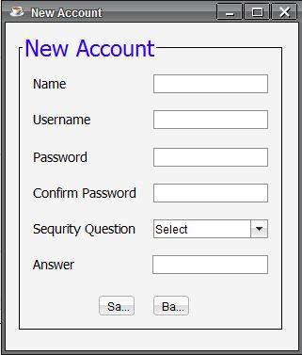

**REPORT**

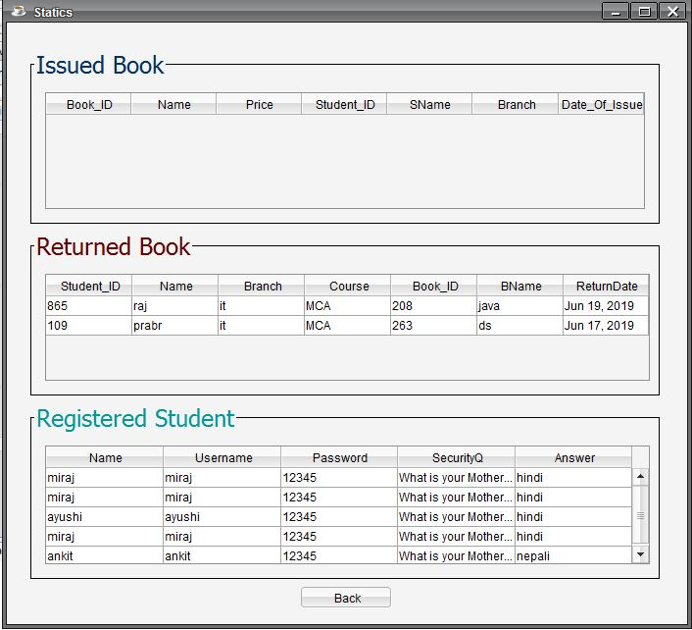

**ISSUE BOOK**

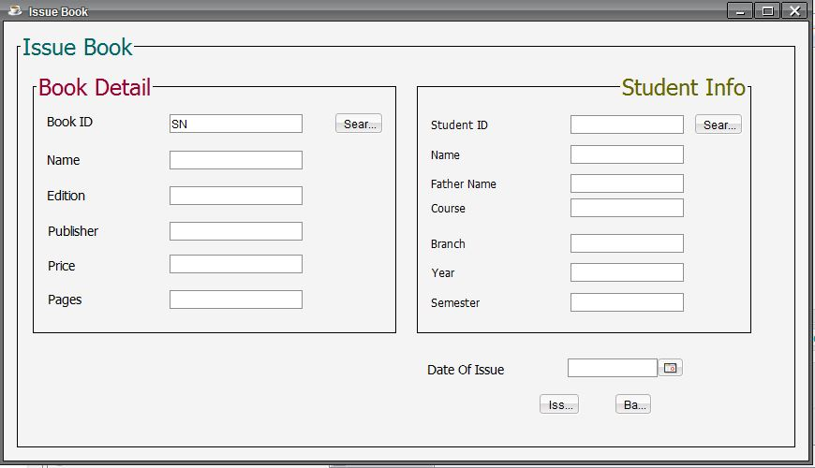

**RETURN BOOK**

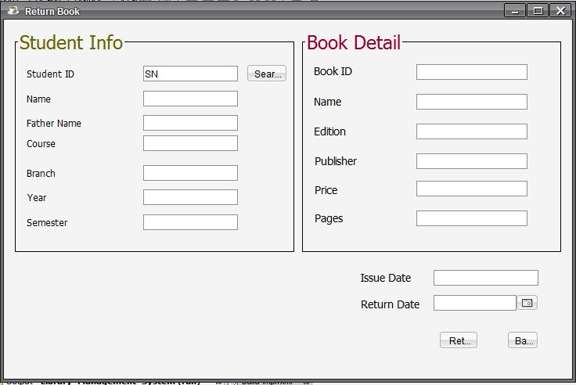

**SEARCH**

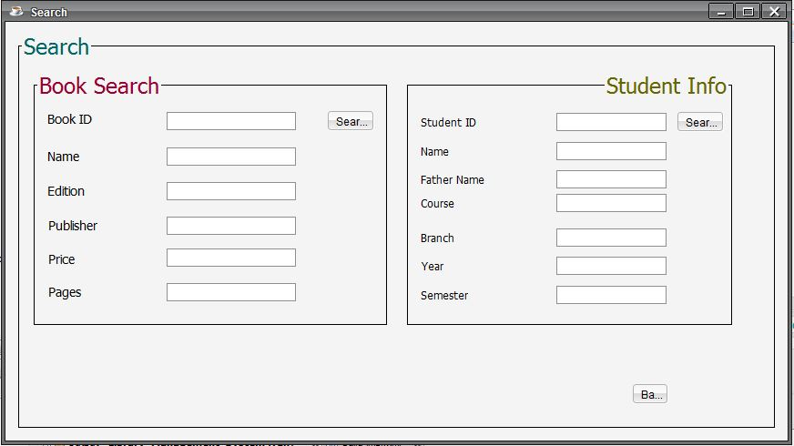

**CONTACT US**

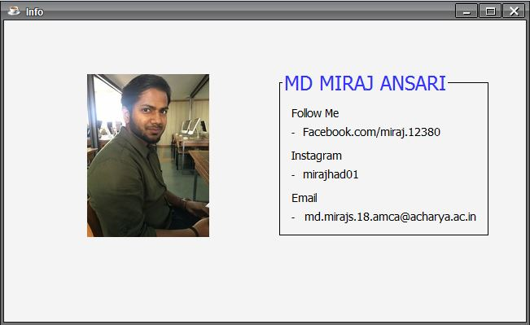

**CONCLUSION & FUTURE SCOPE**

This application provides a computerized version of library management system which will benefit the students as well as the staff of the library.

It makes entire process where student can search books, staff can generate reports and do book transactions. It also has a facility for student login where admin can login and can see status of books issued as well request for book or give some suggestions. It has a facility of teacher’s login where teachers can add lectures notes and also give necessary suggestion to library and also add info about workshops or events happening in our college or nearby college in the online notice board.

There is a future scope of this facility that many more features such as online lectures video tutorials can be added by teachers as well as online assignments submission facility , a feature

Of group chat where students can discuss various issues of engineering can be added to this project thus making it more interactive more user friendly and project which fulfills each users need in the best way possible